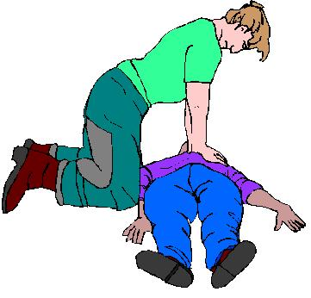CPR / FIRST AID CARDS

